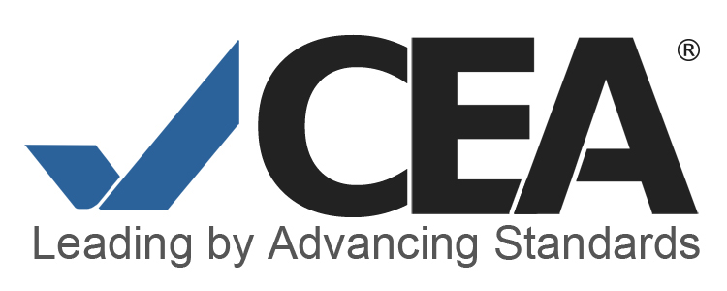
Commission on English Language Program Accreditation
Peer Reviewer Application Form

Submit application packet consisting of the following items: (1) Cover letter, (2) Curriculum Vitae (CV) , and (3) Completed Application Form including names of two professional references by email to Melissa Van De Wege, Accreditation Review Manager at mvandewege@cea-accredit.org

Name/  Email address: |  | Date submitted:
Current Affiliation

Please provide the following information copied from your attached CV.

1. Academic Qualifications:

2. Relevant professional service/memberships/involvement:

- List all current memberships in professional associations.
- Give number of professional presentations within the last 2-3 years (assuming titles have been listed on resume. If not, attach list.)
- Give number of publications (assuming titles have been listed on resume. If not, attach list.)
- List leadership positions in relevant professional associations held (past and present), with dates.
- List professional development activities and events (other than presentations) you have been involved in in the past 5 years.

3. Special domains of expertise:
List number of years of English language program or related experience in these areas.
Area | Years of experience
- Teaching
- Administration
- Budget/finance
- Curriculum development
- Immigration (SEVIS) matters
- Student services
- Placement/assessment
- Working/consulting outside the U.S.
- Other (describe)

4. Program evaluation/consulting experience:
Give a brief description of your role in all evaluation experience you might have had in evaluation processes such as UCIEP program review, CEA self-study, ACCET accreditation, regional accreditation, consulting experience, and other relevant experience.

5. Please list two professional references here with their contact information.

